CALL FOR PAPERS

Under the High Auspices of the President of the Republic of Croatia Prof. Ivo Josipović
Centre for Croatian Studies, Department of Communication Sciences,
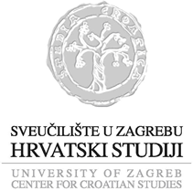
in Cooperation with
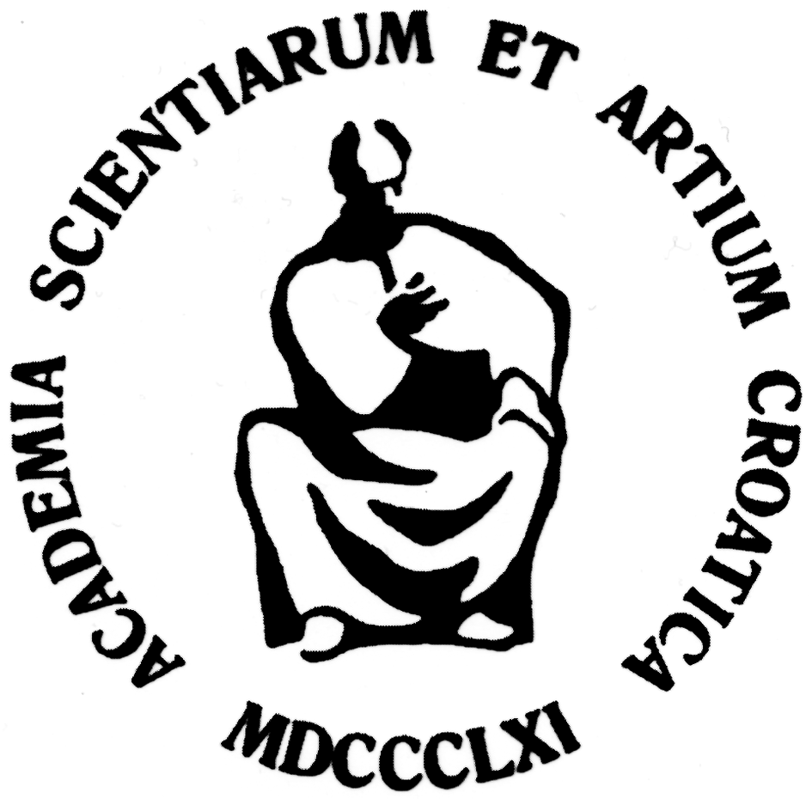
the Croatian Academy of Sciences and Arts
and
the Electronic Media Council
is Organizing
an International Scientific Conference
“Media Literacy in Digital Age – Cultural, Economic and Political Perspective”
Zagreb, June 6-7, 2014
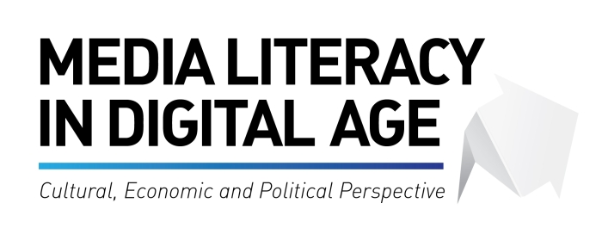
Media literacy - as a concept of empowering the citizens to efficiently deal with the world of traditional and new media, has been in the centre of interest of the international institutions, media experts and scientists for several decades already. UNESCO’s Declaration on Media Education set the framework in the early eighties. Nineteen countries accepted the implementation and improvement of the concept of education for the new digital age, but this did not result in the expected inclusion of media literacy in the national educational systems. The European Union documents emphasize the importance of media literacy for the accomplishment of economic development and social cohesion of Europe by the year 2010, with the focus on the necessity of development of national public policy for the education of citizens in media. European citizens, notwithstanding their age and gender should be media-literate for their active involvement in the exchange of cultural goods and digital economic processes. In the field of human rights, media literacy should contribute to the divergence of freedom in society, political culture and democracy, as well as to the strengthening of the economic system and creative discourse.
In the process, key role is played by the public media services, regulatory bodies and educational institutions which are invited to participate and enable the public a better understanding and awareness of the media contents, processes, technologies and the system of regulation of traditional media such as radio, television, printed media as well as the Internet and the converged media (Ofcom, 2004).
We proudly invite you to participate in the discussion on these issues and to send us your theoretical or empirical research for the conference „ Media Literacy in the Digital Age – Cultural, Economic and Political Perspective”.
Your scientific and professional contributions may involve the following issues:
- What is media literacy and what is its position in relation to information literacy, digital literacy, media education, and media culture?
- What is digital gap and is it possible the overcome it using media literacy?
- Media education for children, parents, teachers and kindergarten teachers.
- Media and information literacy and competitiveness on the European job market.
- The future of traditional media.
- The ethics of communication and the role of media literacy in the protection of privacy, the right to information and the freedom of public speech.
- Participatory journalism.
- The meaning of active use of media.
- The meaning of critical use of media and the ability to critically analyse media contents.
- The role of media literacy in the competitive digital economy.
- Media literacy as the base of social involvement and the quality of life of the citizens of European Union.
- The role of public media in the promotion of media literacy.
- The role of non-profit media in the promotion of media literacy.
- Media literacy in the educational system.
- Media literacy and the protection of copyright.
- Media literacy and the political culture of citizens.
- Media literacy and the crises of society.
***
The official languages of the meeting are Croatian and English. Full papers should be sent in English by June 30, 2014 to media.literacy@hrstud.hr. Papers will undergo double blind peer review and will be published in the special edition of the Media Research journal (indexed in Sociological Abstracts (SA), Linguistic and Language Behavior Abstracts (LLBA) and Social Planning/Policy & Development Abstracts (SOPODA), Current Index to Journals in Education (CIJE), and SCOPUS). Guide for authors will be available on the website of the conference: www.hrstud.unizg.hr .
Conference Board: Nada Zgrabljić Rotar, Damir Hajduk, Jelena Jurišić, Danijel Labaš.Scientific Programme Board: Nada Zgrabljić Rotar, Jelena Jurišić, Danijel Labaš, Tomislav Janović, Ivan Burić, Blanka Jergović, Damir Hajduk.
Organization Assistance: Ifigenija Račić, Anja Raguž, Lana Ciboci, Mirta Seferović, Matea Horvat. IT Assistance: Tomislav Knežević.
-----------------------------------------------------------------------------------------------------------------

